**EPR - fortifying the safety of Nuclear Energy**

The ever-growing energy demands call for improvement in existing nuclear reactor technologies. This includes the need for higher yields with lesser fuel inventory while keeping in mind the safety aspects associated with the design features of the nuclear reactor. From a design perspective, the safety of a nuclear reactor depends on the concept of "defence-in-depth". This approach provides a hierarchical deployment of equipment and procedures to maintain the effectiveness of the three important physical barriers against the release of the radioactive fission products to the environment:

1. the fuel cladding (present around the point of fission products generation);
2. the reactor vessel (contains all the fuel elements forming a reactor core) and;
3. the leak-tight containment (to prevent fission products from escaping to the environment.

The EPR (European Pressurized Reactor or Evolutionary Power Reactor) technology takes into account all the above key requisites while setting the standards for the future nuclear generation. Developed by the joint effort of France's Areva NP (now Framatome), EDF (Électricité de France) and Siemens (Germany) in 1989, this Generation III Pressurized Water Reactor is inspired from 30 years of experience acquired in the design and operation of nuclear plants.

The cornerstone of the EPR design philosophy is its improvement on the “defence-in-depth” concept on all levels, resulting in very high safety standards. This includes the provisions related to:

1. deployment of four independent emergency cooling systems, each being 100% capable of ensuring safe reactor shut-down regardless of the circumstances;
2. presence of an outer reinforced concrete shell over the reactor containment building to protect against the risk of external attack, and;
3. installation of "core catcher"- equipment specifically designed to recover, contain and cool the reactor core in the event of a core meltdown accident.

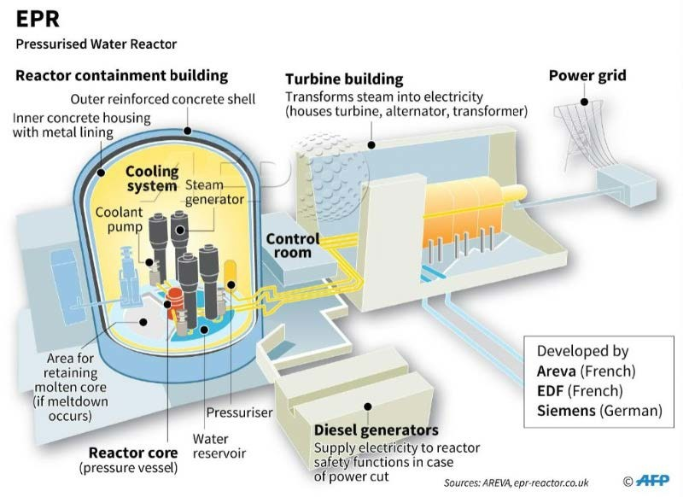

EPR: Design overview [(http://www.nuclearbusiness-platform.com/nuclear-industry/epr-technology/)](http://www.nuclearbusiness-platform.com/nuclear-industry/epr-technology/)

Apart from design improvements, EPR technology also provides economic competitiveness through improvements over older Generation II reactors. These provisions include enhanced fuel utilization thereby needing 17% less fuel, the flexibility of using different fuel variants due to large operating margins, the increased power generation efficiency and lifetime (36-37% and 60 years in comparison to the 33% efficiency and 40 years lifetime of Generation III PWRs). With these parameters, the EPR technology provides a good transition for the arrival of the next Generation IV reactors that will follow.

**Current EPR units across the world:** Apart from the Finnish [Olkiluoto 3](https://en.wikipedia.org/wiki/Olkiluoto_Nuclear_Power_Plant" \l "Unit_3) reactor which is scheduled to be online in March 2021, 6 EPR unites are currently under construction around the world. These projects include:

1. [Flamanville3](https://www.edf.fr/en/groupe-edf/producteur-industriel/carte-des-implantations/centrale-nucleaire-de-flamanville-3/presentation) (France);
2. [Taïshan 1 and 2](https://en.wikipedia.org/wiki/Taishan_Nuclear_Power_Plant) (China), and;
3. 4 reactors in the UK, the first two being constructed at the [Hinkley Point C](https://en.wikipedia.org/wiki/Hinkley_Point_C_nuclear_power_station) site.

**References:**

1. [EPR design description, Framatome ANP, Inc. August 2005.](https://www.nrc.gov/docs/ML0522/ML052280170.pdf)
2. <https://www.edf.fr/en/the-edf-group/our-commitments/innovation/the-epr-is-a-third-generation-reactor-the-most-powerful-in-the-world>
3. <http://www.nuclearbusiness-platform.com/nuclear-industry/epr-technology/>